One: The win10 system is the first time to install the V1.11.5~8 version SDK, the following prompts may appear:

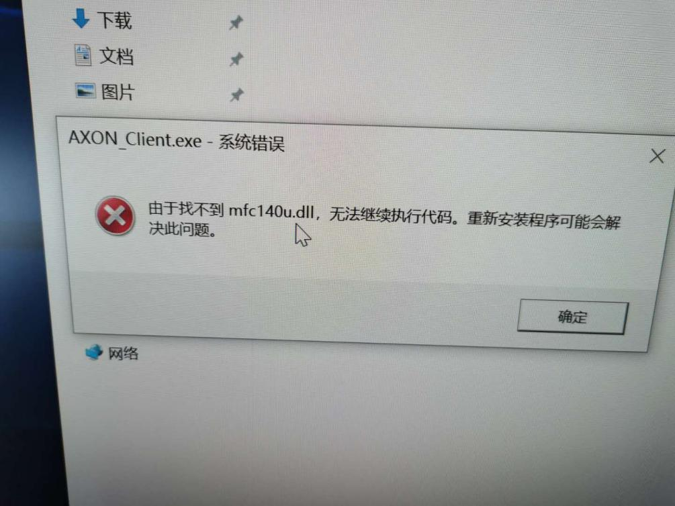

Method: Copy the mfc140u.dll file to the installation directory and re-open the client as an administrator.

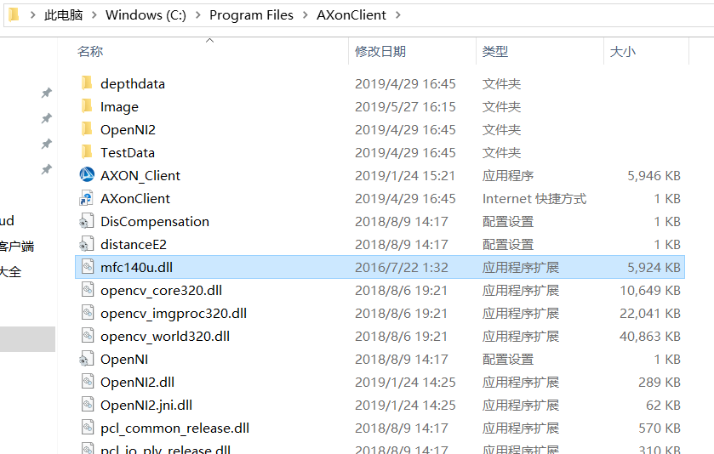

**Note: Subsequent versions will be fixed, temporarily resolved according to this method.**

